**ITCS333 Internet Software Development**

**Assignment 1: Web Design using HTML and CSS**

**Deadline: 1 Week**

**Part 1: Website Design [without bootstrap]**

Design the above website template (index.html) with the following requirements:

1. Both top header and bottom footer must be fixed (not scrollable).✅
2. Use flex box model to structure the website✅
3. Use CSS formatting to match the design above as much as possible✅
4. Top right navigation, ✅
   1. Home takes you to index.html (Homepage)
   2. Services takes you to any website of your choice
   3. About Us takes you to aboutus.html: general info about yourself.
5. Make the LOGO image clickable that takes you to index.html ✅
6. In the left side (YELLOW):
   1. Add a nice centered image ✅
   2. Add 3 vertical navigation links and style them so they look like a nice buttons stacked over each other ✅
      1. First link takes you to your current Course Schedule, using HTML Table
      2. Second link takes you to general info about yourself (About us)
      3. Third link takes you to contact us HTML form.
   3. Change the yellow background to a transparent color of your choice ✅
7. In the right side main section (PINK):
   1. Display 3 horizontal info cards (should contains font awesome icons, title, text). The card box should have shadow and rounded corners. Make the three cards looks nice by adjusting the padding/margins and other CSS properties.
   2. Change the pink background to a transparent color of your choice
   3. Once the template index.html is complete, make three copies and rename them as follows:
      1. **Myschedule.html**: replace the main section (pink) with an HTML table showing daily lectures and lab timings. Use CSS to format the table. ✅
      2. **Aboutus.html**: replace the main section (pink) with info about yourself (paragraphs + image). List your hobbies using under unordered list. Use proper CSS to format your info. ✅
      3. **Contactus.html**: replace the main section (pink) with an HTML form that uses labels, text box, radio button, checkbox, drop-down and a submit button. Use proper CSS to format your form. ✅

**Part 2: Responsive Webpage Structure [without bootstrap]**

Design a responsive webpage using media query as shown in the following image. Your design should have three views namely Desktop, Tablet and Mobile views. Your final answer should looks similar to the given examples using the required CSS styles. ✅

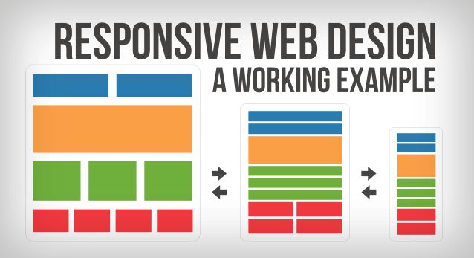

**Part 3: (Bootstrap)**

|  |  |
| --- | --- |
| **Given the following CSS** | **Write the required bootstrap/HTML to do the following:** |
|  | Large View   |
|  |  |
| Medium View   | Small View   |

Your Bootstrap/HTML code should correspond to the following requirements:

* The box1, box 2 and box 3 should be part of a container that has light blue background (use the given CSS) covering the entire window width. This container should be fixed, not scrollable using bootstrap class. ✅
* Each box should have the properties defined in the given CSS. ✅
* Using bootstrap classes:
  + In large view: ✅
    - 1st row: has 3 boxes (box 1 is twice the size of box 2 or box3)
    - 2nd row: has 2 boxes (box 4 is twice the size of box 5)
    - 3rd row: has 2 boxes (box 7 is twice the size of box 6)
  + In medium view: ✅
    - 1st row: has 2 boxes (box 1 is twice box 2). Box 3 is turned off.
    - 2nd row: has 1 box taking full width.
    - 3rd row: has 1 box taking full width.
    - 4th row: has 2 boxes (box 6 and box 7 has the same size)
  + In small view: ✅
    - 1st row: has 2 boxes (box 1 and box 2 has the same size). Box 3 is turned off.
    - 2nd row: has 1 box taking full width.
    - 3rd row: has 1 box taking full width.
    - 4th row: has 1 box taking full width. Box 7 is turned off.